This ACE Technical Document is intended for ACE representatives only. It was created to present the ACE philosophy and help further the understanding of the technical aspects of the selective soldering process when discussing ACE products with a client.

**Solder Wave Stability**

Many techniques are used by the various Selective Soldering machine manufacturers to pump molten solder to the nozzle. The standard method however is the time tested conventional impeller design used on wave soldering machines and in fact most of all pumps for any purpose. This design, although reliable and relatively low maintenance, naturally causes pulsing due to the impeller vane rotation.

ACE though, has solved the pulsing issue. The ACE design uses a CNC machined impeller that delivers a precise volume of solder between each vane. As the solder moves towards the nozzle, there is a “serpentine” delivery channel causing back-pressure in the stream. Each back-pressure point tends to mitigate the pulse of the impeller vanes. We machine in sufficient back pressure points to cause the solder to be very steady when it reaches the nozzle.

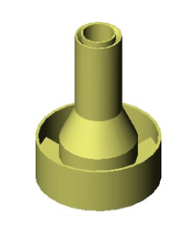The KISS wave is further stabilized by a dual moat system built into each nozzle. At the tip of each Bullet nozzle there is a groove machined around the orifice. The groove acts as a concentric ring of resistance creating back pressure towards the center of the nozzle resulting in the unique “Bullet” shape. A 2nd back pressure function is achieved with a collar at the base of the nozzle. The collar collects the molten solder allowing it to escape from the base of the collar at 90-degree spacing. The consistent back pressure collected in the collar migrates up to the nozzle tip edges further assisting in wave stability.

For these reasons, the ACE system provides an extremely reliable and smooth solder wave.